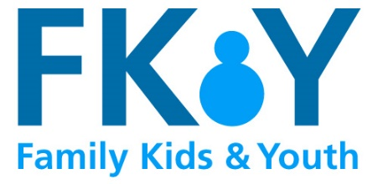
The Mix: 0808 808 4994 A free telephone, webchat and email listening service that provides confidential emotional support and can offer signposts to relevant services. http://www.themix.org.uk/

Youth Access: The largest provider of young people's advice and counselling services in the UK. http://www.youthaccess.org.uk/

SHOUT: TEXT 85258 Shout is the UK’s first 24/7 text service, free on all major mobile networks, for anyone in crisis anytime, anywhere. It’s a place to go if you’re struggling to cope and you need immediate help. https://www.giveusashout.org/

Childline: 0800 1111 ChildLine is a counselling service for children and young people. You can contact ChildLine about anything - no problem is too big or too small. http://www.childline.org.uk/pages/about.aspx

Supportline: 01708 765 200, email info@supportline.org.uk – Supportline provides a confidential telephone helpline offering emotional support to any individual on any issue. http://www.supportline.org.uk/problems/support_children_young_people.php

Cybersmile: Offers counselling and advice to young people who are being abused or in distress. https://www.cybersmile.org/

Calm: 0800 58 58 58 Offers support to men in the UK, of any age, who are feeling down or in crisis via helpline, webchat and website. https://www.thecalmzone.net/

Young Minds https://youngminds.org.uk/ gives a comprehensive guide online to support and help young people and parents and other adults who may be struggling with their wellbeing.

Heads Together https://www.headstogether.org.uk/ has just launched an online guide on Instagram to support mental health for people of all ages.

